Determining Honey Bee Behaviors from Audio Analysis

Loren Hord and Errol Shook
National Science Foundation Research Experience for Teachers
Appalachian State University
Abstract: Honey bees are an integral part of agriculture and the need to monitor bee activity has become more apparent in light of Colony Collapse Disorder (CCD). The sound frequencies that honey bees emit may be subtle indications of the health and behavior of the hive. Using computer frequency analysis, it is possible to infer if there are patterns in the audio frequencies from a hive before and after a swarm. These inferences can help apiarists care for honey bees and adjust beekeeping practices to meet the needs of their hives. This research suggested that within the observed hives, one had recently swarmed, one was preparing to swarm and two hives were content. All of the beehives that were studied were completely healthy with no signs of CCD. The results of the research support previous research in the field of honey bee audio analysis.

- INRTODUCTION
The Western Honey Bee (Apis mellifera L.) is vital to the agricultural production of the areas it inhabits. In order to insure the vitality of honey bees for the future, it is imperative to develop techniques to gather and interpret data about beehives and their health. The analysis of the sounds bees produce seem to be a promising way to understand what is going on in a hive. Honey bee audio has a long history of being analyzed to draw conclusions about a hive. Now, with modern computing techniques, researchers can be more precise with interpretations of the sound. Combining Biology, Computer Science and Audio Engineering scientists gain an improved view inside the hive and will help to solve the mystery of Colony Collapse Disorder.
In order to decipher honey bee audio, it is important to classify the sounds that bees make and the bee caste system. Every hive consists of one queen that is the only fertile female in the hive. Worker bees are all infertile females and all drones are male. [8] There are four major sounds that bees make: flying, fanning/warbling, hissing and piping. Each sound has a specific meaning and the frequency or amplitude that each sound is emitted can lead to deeper interpretations of the nature of the hive. [5] A technology company called Bee Alert Technology Inc. has found that the insects buzz differently when exposed to various poisonous chemicals. [13]
- PREVIOUS RESEARCH
The bee sound people are most familiar with is the buzz they emit when flying. This sound tends to resonate at a frequency of approximately 250 Hz for a worker bee and 190 Hz for a drone bee. [8] Bees younger than nine days old resonate a slightly higher frequency because their wings have not yet hardened. This sound is not only made by the wings of the honey bee; the spiracles, holes in the abdomen and thorax that allow the bee to breathe, also contribute to the sound and its flight. The spiracles vibrate in a way similar to the way a trumpet player’s lips vibrate. These vibrations are synchronised with a honey bees wings and contribute to the amplitude, or volume, of the sound. [8]
Fanning is a process worker bees do to ventilate the hive for cooling and the evaporation of water from nectar. The warble sound is the dull hum made inside the hive caused by worker bees fanning. This sound resonates at frequencies between 225 – 285 Hz. [5] Since this is around the same frequency as bees in flight, it is important to record warbling at night to avoid confusing the sounds. The warble sound is believed to be one of the most indicative tones bees produce to interpret behavior. [8]
Warbling analysis is used to predict when a hive of honey bees is ready to swarm. A swarm is when the queen leaves the hive with a large number of worker bees to create a new hive. A beehive will swarm because of overcrowding in the hive, discontent or the arrival of a new queen. The warbling sound will increase in amplitude up to three weeks before the swarm. There are many devices made to specifically analyse this sound such as E.F. Woods’ Apidictor from the 1950s and even iPad apps such as “Swarmy”.[5]
The hiss sound honey bees produce is a defensive reaction to potential threats to the hive. This sound resonates at a frequency of about 3000 Hz. [8] Apiarists sometimes knock on the side of a hive at night to listen to the nature of the bees’ hiss. The length and intensity of the hiss is indicative of an impending swarm. A normal hiss, where bees are protective of their hive and brood, will last only half of a second and will be louder than their current warbling. If a hive is preparing for a swarm, the hiss will start and stop more slowly and have a lower sound intensity. The reason for the change to a more apathetic hiss sound is that when the bees are planning to swarm, they have little or no brood to protect and are not as protective of a hive they are about to abandon.
The final and rarest sound that can be heard in a hive is a queen bee piping. This sound is emitted by a queen bee through her spiracles and is a challenge to all other potentially fertile female worker bees who could be queen. It is typically described as a loud hooting or quacking sound that, while a queen bee is in her cell, emits a frequency of about 450 Hz, then 340 Hz after she emerges from her cell and decreases in frequency as the queen ages. [5] The behavior of the piping sound can be seen in the Spectrogram and Frequency Analysis in Figures 1 and 2 below. The spectrograms fall within the normal healthy range of queen bee piping sounds.
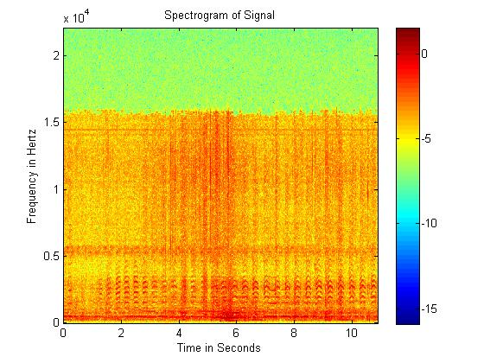
Figure 1 – Spectrogram of a queen bee piping

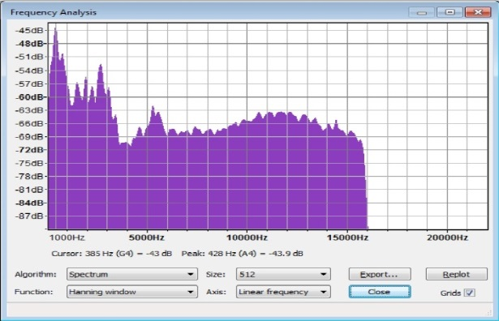
Figure 2 – Frequency Analysis of a queen bee piping

As stated by the European Commission on honey bee Health, scientifically sound and uniform testing is a fundamental element for reliable disease diagnosis. These methods are crucial, considering the necessity of honey bees to agriculture. “One mouthful in three of the foods you eat directly or indirectly depends on pollination by honey bees.” [9] Almost 20 percent of all flowering plants are pollinated by honey bees. When weighing the importance of bee pollination, farmers don’t want to depend on wild honey bees. That is why the value of honey bee pollination to the U.S. agriculture is worth more than $14 billion annually. With statistics like these, the importance of bees and the necessity to find a way to identify problems within a hive are profound. [9]
There are many factors that contribute to the problems that honey bees are currently facing. These factors include parasites, disease, genetics, poor nutrition and pesticide exposure. [7] In October 2006, one of the first of recent widespread disappearances of adult worker honey bees in Europe and North America occurred and was from then on referred to as Colony Collapse Disorder (CCD). Beekeepers began reporting losses of 30-90% of their hives. [9] New virus species and the Varroa mite are recognized as major contributing factors to colony loss in the U.S. and other countries. [7]
The main symptom of CCD is very low or no adult honey bees present in the hive while a live queen remains. Also, there are no dead honey bee bodies present in the hive. [9] After the disappearances, there is still honey, pollen and immature bees (brood) in the hive. Colony losses each year are not unexpected, but the magnitude of losses with CCD is extremely high. There have been reports of large number of disappearing bees in the 1880s, 1920s and 1960s, but because of a lack of data there is no way to know for sure whether those problems were caused by the same agents as CCD. [9] In order to combat these issues contributing to the loss of honey bees and record the proper causes, new and old techniques must be used.
In 1950 Edward Woods reported in a lecture to the Central Association of Beekeepers on the relationship between the sounds bees make and their health. [8] Since then, audio analysis has been a major method used to interpret what is going on in a beehive. Woods was an audio engineer for the BBC and started beekeeping during World War II when Britain began their ‘Dig for Victory’ campaign. At that time, the British government asked citizens to produce their own food in case of a blockade. Over the years Woods designed many portable devices, such as the Apidictor, intended to predict bee swarming and other behaviors. Edward Woods started a whole new process for gathering data from a beehive. [5]
- METHODOLOGY
This research studied four beehives, labeled One, Two, Three and Four, that were labeled in a yoard in Boone, NC. Audio recordings were to compare and contrast the behaviors of each hive. The four hives were in various stages of development, including one that had already swarmed. The bees are kept in standard Langstroth Hives that contain two to three supers (chambers). The four hives are part of a larger number of hives used in bee research at ASU.
The bee audio on July 10th and 12th, 2013 were recorded with Pro Tools HD 9 on an Apple MacBook Pro. The microphone used was a Sterling Audio ST31. The ST31 is a small diaphragm FET hypercardioid condenser microphone. The condenser microphone was selected to be able to get strong audio signals from the beehive, while its polar pattern was necessary to eliminate background noise. The analog to digital converter used was the M-Audio MobilePre. The digital camera used to record the June 6th, 2013 swarm was a Lorex WL2300.
The bee recordings were made between 11:00AM and 12:00PM on July 10th and 12th, 2013. The microphones were placed outside of the hive directed in the approximate center of the entrance above the bottom board, as seen in Figure 3 and 4. This allowed the microphone to not only hear the inside of the hive, but to also capture the sound of the bees entering and exiting the hive. Prior to recording, it was known that one of the hives had swarmed within the last six months and that one hive was believed to be preparing to swarm. The goal of this research is to determine if there are patterns within the audio frequencies emitted by a hive of bees before and after a swarm.
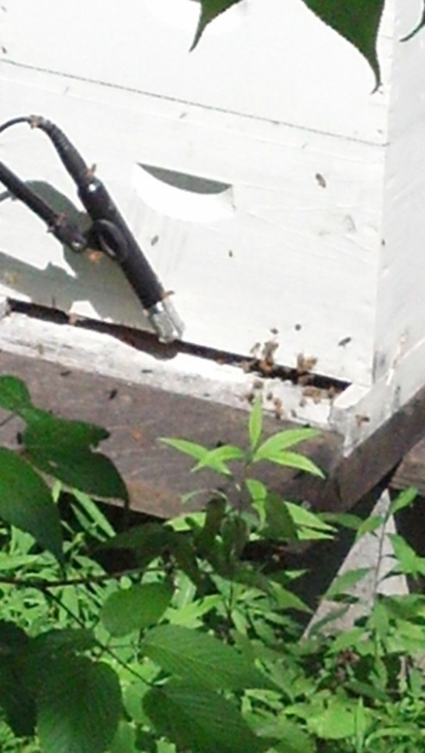
Figure 3 – Microphone placement outside of the hive

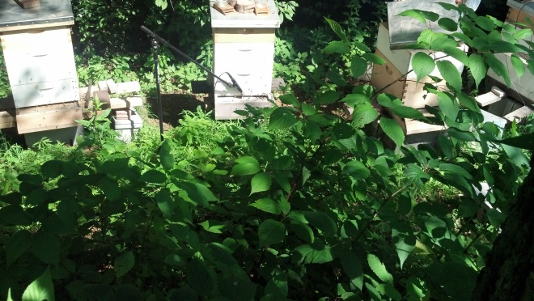
Figure 4 – Hive and microphone placement

- ANALYSIS
To articulate what sounds bees produce the loudest, graphs to draw inferences between sound frequency and amplitude are selected. From the research, the comparison between the frequency and amplitude are the measurements that are the most useful when deciphering the nature of a beehive. Abnormal frequencies or amplitudes tend to be associated with certain hive dispositions, such as being sick, swarm preparations, EMF etc.[3] After recording the sounds from the hive, several computer programs are utilized to examine the audio.
To analyze the audio recordings Excel, Audacity, Octave and MATLAB proved to be vital to deciphering the behavior of sound coming out of the beehive. The duration, frequency and amplitude (volume) of each sound are measured. With this precision, and the ability to visualize the sound, patterns become more apparent. Each program plays a specific role and helps to model the nature of the hive in different ways.
Audacity is an audio analysis program that was a basis for the file conversion and frequency analysis. This freeware program allows users to import different audio file types and convert them to a wave (.wav) file format. Audacity is also used to create Spectrograms of the sound files to compare frequency and amplitude over time. Excel, Octave and MATLAB were all used similarly to create spectrograms and line graphs of the bee sounds comparing frequency and amplitude over time.
Figure 5 shows a picture of a swarm from Hive Four that occurred on June 6th, 2013 between 2:02 pm and 2:53 pm and Figures 6 - 11 illustrate the sound intensity. The color scale measures sound intensity in decibels. Each figure represents a ten minute audio recording. Notice the change in intensity of sound during the peak of the swarm in Figures 7 and 8. The darkest band, at the bottom, indicates that the frequencies around 250 Hz were the most predominant. This suggests that this was a typical swarm of normal healthy bees.
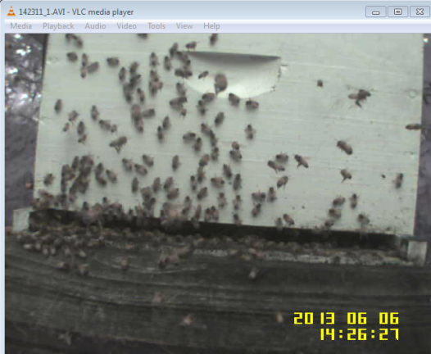
Figure 5 – Hive Four during the swarm
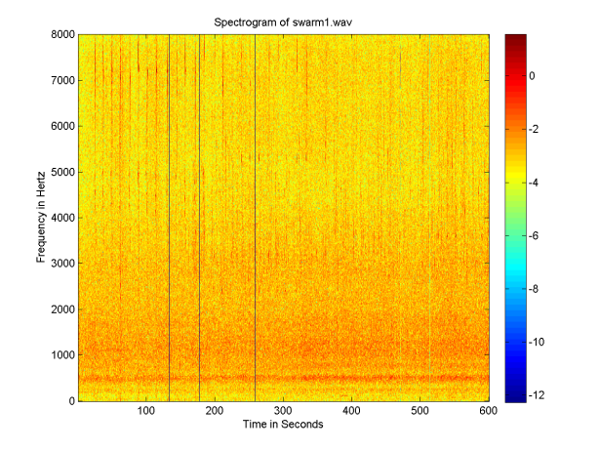
Figure 6 – Honey bee swarm at 2:02PM
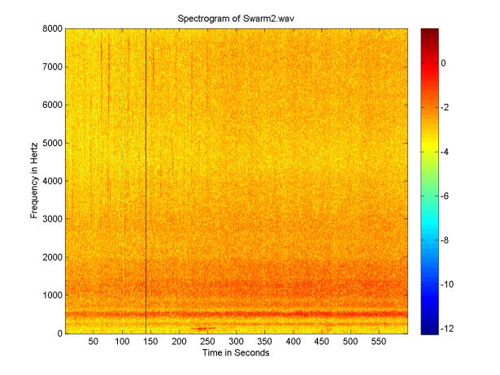
Figure 7 – Honey bee swarm at 2:12PM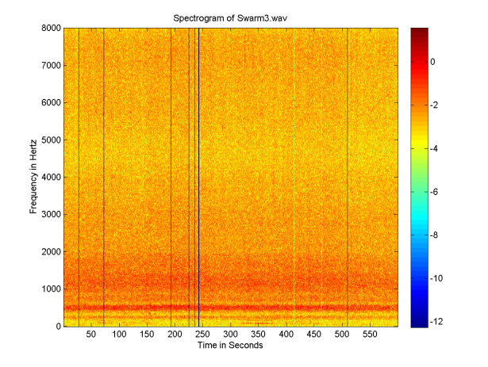
Figure 8 – Honey bee swarm at 2:23PM
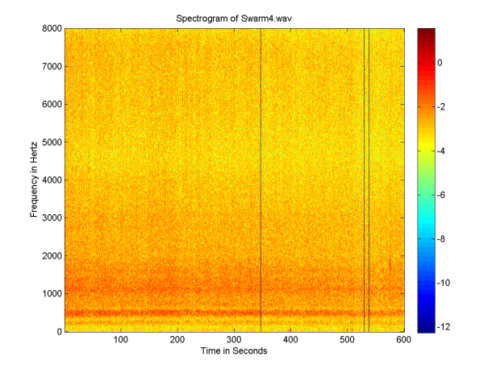
Figure 9 – Honey bee swarm at 2:33PM
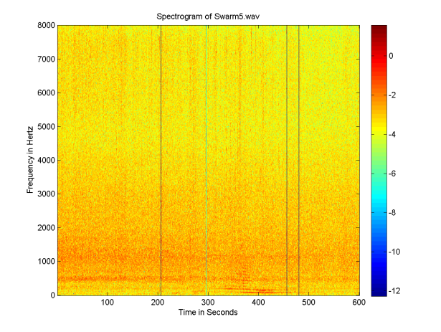
Figure 10 – Honey bee swarm at 2:43PM
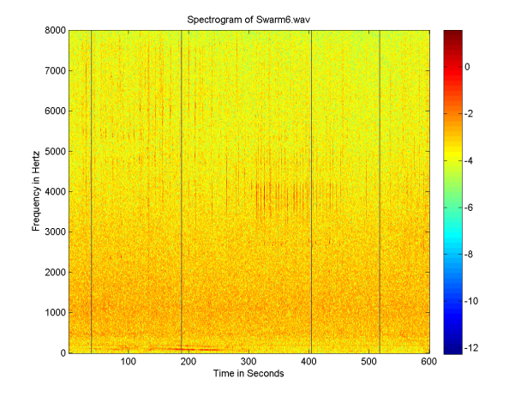
Figure 11 – Honey bee swarm at 2:53PM

The next eight figures represent the audio recordings for each hive on July 10th and 12th. On both dates Hive Four appears to have the lowest sound intensity. This seems reasonable considering Hive Four had a swarm on June 6th. Hive Two has the highest sound intensity on both dates, which could indicate an impending swarm. Hives One and Three appear to be of medium sound intensity. This could indicate that they are normal healthy hives that have not swarmed recently nor are ready to swarm. Note that the blue bar on the right side of the graph for Figure 19 indicates that the audio recording was slightly shorter in length than the other recordings.

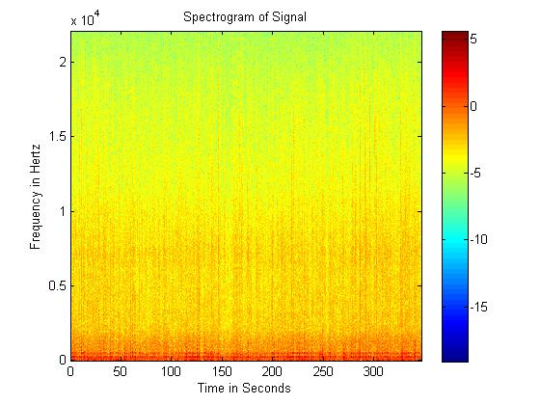
Figure 12 – Hive One July 10th, 2013
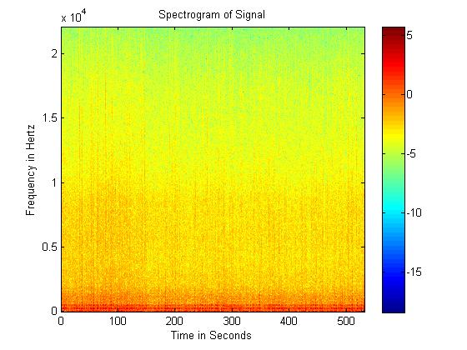
Figure 13 – Hive Two July 10th, 2013
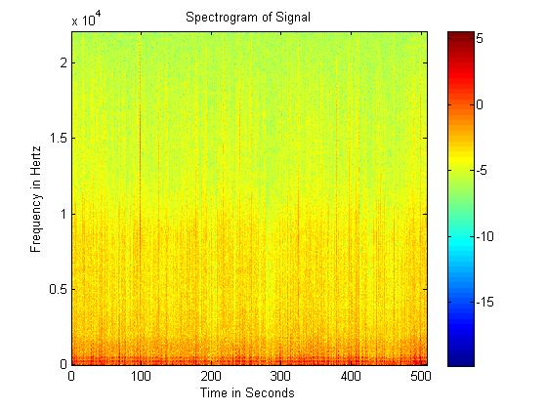
Figure 14 – Hive Three July 10th, 2013
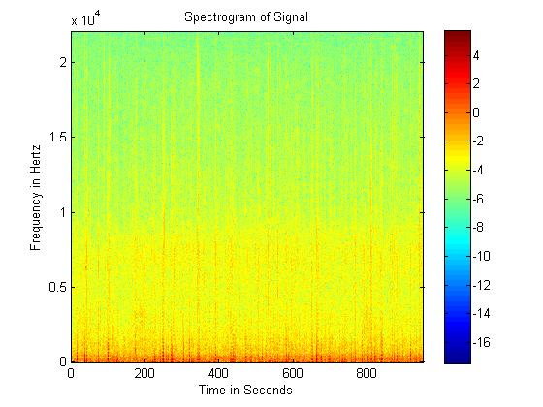
Figure 15 – Hive Four July 10th, 2013

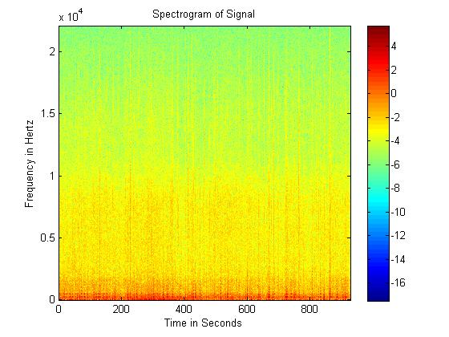
Figure 16 – Hive One July 12th, 2013
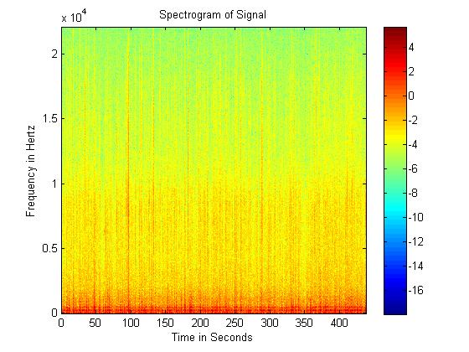
Figure 17 – Hive Two July 12th, 2013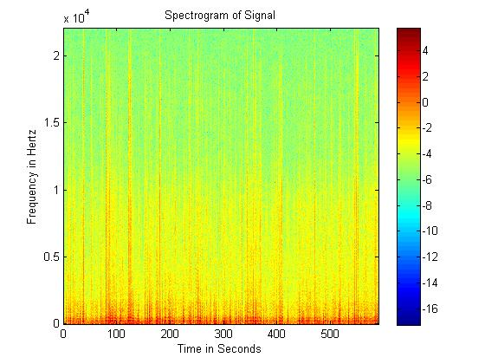
Figure 18 – Hive Three July 12th, 2013
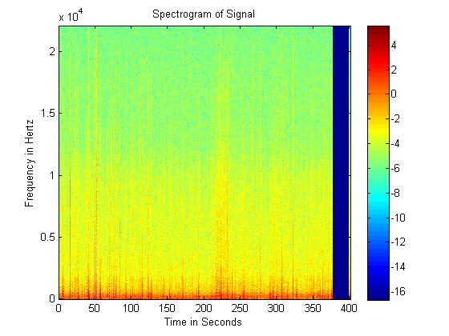
Figure 19 – Hive Four July 12th, 2013

Figures 16 and 17 both show the comparison of the frequency and amplitude of each hive on July 10th and 12th. On both days Hive Two was the loudest and Hive Four was the quietest. Hives One and Three stay consistently in the middle. These results support the fact that Hive Four has swarmed recently and could indicate that Hive Two is preparing to swarm.

Frequency
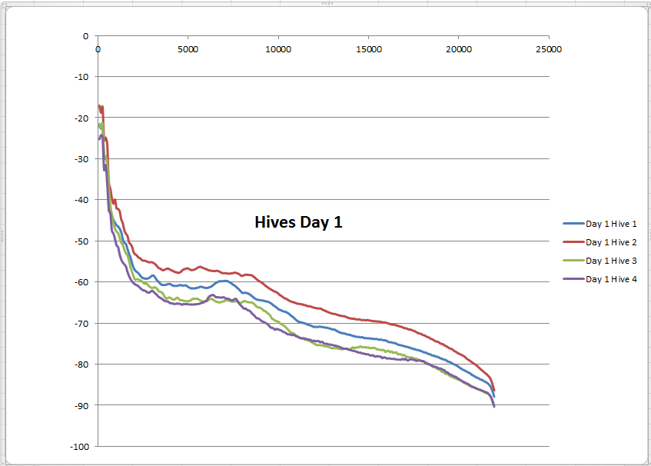
Volume
Figure 20 – The four hives July 10th, 2013

Frequency
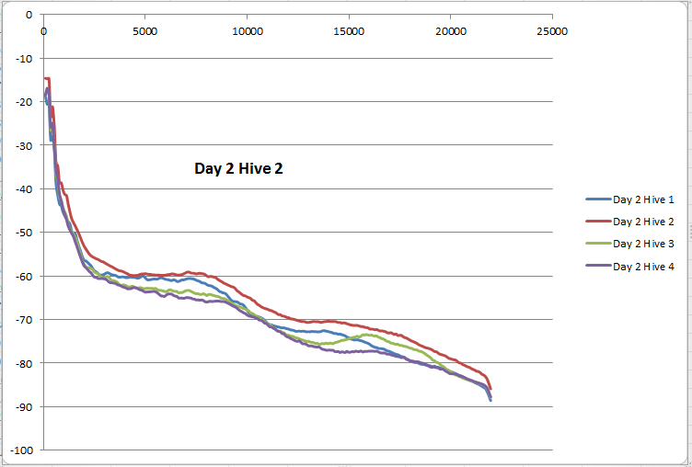
Volume
Figure 21 – The four hives July 12th, 2013

In Figure 22 the frequency analysis of a hive is related to recordings of a single bee and three bees. The trends for all three recordings are the same, which suggests that the bees emit the same tone alone, in a small group or in the collective hive. The main difference between the graphs is the amplitude because the volume of a whole hive is louder than three bees or just a lone bee.
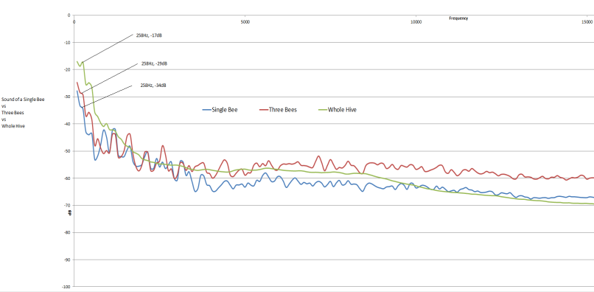
Volume
Frequency
Figure 22 – One bee, three bees, hive

- CONCLUSIONS
After analyzing the audio recordings, several conclusions can be inferred about the honey bees that were studied. All of the bees appeared to be healthy and were emitting tones that are in the normal frequency range for bees of this species. Hive Four was known to have swarmed on June 6th, 2013 and the hive’s volume supported this fact. Hives One and Three appeared to be strong healthy hives with a volume that was not indicative of an impending swarm. Hive Two’s volume and activity suggests that a swarm could be imminent, given enough days of warm sunny weather. More information could be derived from the bee hives given observation over several seasons.
Future long term studies need to include 24 hour observational techniques over long periods of time. This would help to give a more cohesive look at the bees’ behavior. Other factors that could be studied would include the effects of genetically modified plants on bee health, possible diseases or Varroa mites in the area or cyclical genetic factors. All of these factors are crucial to understanding the mystery of Colony Collapse Disorder.
- ACKNOWLEDGMENTS
We would like to thank the National Science Foundation for funding the Research Experience for Teachers. We would also like to thank Dr. Rahman Tashakkori for access to the Appalachian State University beehives and Dr. R. Mitchell Parry for assistance with MATLAB and Octave. A special thank you goes to Dakota Murray, Amad Ghadiri, Clint Guin, Nathan Hernandez, Michael Crawford and Bahar Akhtar for daily assistance with this project.

- REFERENCES
[1] Adrian M. Wenner. (2013). Sound Communication in Honeybees. Beesource. [Online] Available:
http://www.beesource.com/point-of-view/adrian-wenner/sound-communication-in-honey-bees/
[2] Mark Ward. (2012, Jan.). Bee Hive Hums Recorded to Monitor Insects’ Health. BBC. [Online] Available: http://www.bbc.co.uk/news/technology-16114890
[3] Madrona Murphy and Russel Barsh. (2013, Jun.). The buzz about EMF. Islands Weekly. [Online] Available: http://www.islandsweekly.com/news/212490671.html
[4] Seiya Tsujiuchi. (2007, Feb.). Dynamic Range Compression in the Honey Bee Auditory System toward Waggle Dance Sounds. PLOS one. [Online] Available: http://www.plosone.org/article/info:doi/10.1371/journal.pone.0000234
[5] (2013). Acoustic Analysis of Bee Behavior – Part 1. Bee Hacker. [Online] Available: http://www.beehacker.com/wp/?page_id=103
[6] Kevin J. Hackett. (2004, Mar.). Bee Benefits to Agriculture. USDA. [Online] Available: http://www.ars.usda.gov/is/ar/archive/mar04/form0304.pdf
[7] Molly Hooven. (2013, May). USDA and EPA Release New Report on Honey Bee Health. United States Environmental Protection Agency. [Online] Available: http://yosemite.epa.gov/opa/admpress.nsf/0c0affede4f840bc8525781f00436213/e04602a5e7aa060685257b5f004a12d3!OpenDocument
[8] Rex Boys, Listen to the Bees. The Cottage GL20 7ER. 1999
[9] Kim Kaplan. (2013, May). Honey Bees and Colony Collapse Disorder. United States Department of Agriculture. [Online] Available: http://www.ars.usda.gov/News/docs.htm?docid=15572

[10] Elton Robinson. (2012, Sept.).Honey Bees in Need of Sound Science. Western Farm Press. [Online] Available: http://westernfarmpress.com/management/honey-bees-need-sound-science
[11] EFSA. (2013, July). Bee Health. European Food Safety Authority. [Online] Available: http://www.efsa.europa.eu/en/topics/topic/beehealth.htm
[12]Directorate-General for Health and Consumers. (2010, Jun.). European Commission on Honey Bee Health. [Online] Available: http://ec.europa.eu/food/animal/liveanimals/bees/docs/honeybee_health_communication_en.pdf
[13] Cary Shimek. (2007, Apr.) The Buzz on Bees. Research View. [Online] Available: http://www2.umt.edu/urelations/rview/spring07/bees.htm

