- Brewers yeast
- Soy flour
- Vegetable oil (linseed, olive, canola, hemp oil)
- Vitamins and minerals
- Probiotics
- Pea protein
- Hemp protein
- Rise protein
- Egg protein
- Hidroprot
- Essential oils (lemongrass, spearmint, тимол)
- Кверцетин, ресвератрол
- Кумаринова киселина (1мг на 1кг), канелена киселина
- Танин
- Имуноглобулини (витамин А, витамин Е, Цинк, доматен сок)
- Витамин К (в пергата)
- Чай от коприва
- Soy milk (estrogen)
- Wheat gluten
- Glutamine amino acid
- Digestive enzymes
- Cartenoids – pollenkitt in pollen
- Галова киселина в сиропа (тетра, ройбос екстракт)
Amino-acid | Minimum required % of amino-acid in protein digested
Threonine | 3
Valine | 4
Methionine | 1,5
Leucine | 4,5
Iso-leucine | 4
Phenylalanine | 2,5
Lysine | 3
Histidine | 1,5
Arginine | 3
Tryptophan | 1

Ingestion and Digestion
Food enters the alimentary canal (fig. 1) by way; of the month and passes through the esophagus to the honey stomach. In the honey stomach hydrolyzing enzymes break down the principal sucrose of nectar to the simpler monosaccharides glucose and fructose present in honey. Immediately behind the honey stomach is the proventricular value or honey stopper. It retains the nectar load in the honey stomach, controls passage of food into the midgut or ventriculus, and prevents food substances in the midgut from returning to the honey stomach. The midgut is a relatively large segment of the alimentary canal, where food is temporarily stored and most digestion occurs. The inner wall of the midgut is lined with a peritrophicm membrane, presumably to protect the cells from damage by the gut contents. The alimentary canal is completed by a short small intestine and a large intestine or rectum that comprises the hindgut where food digestion is completed. Undigested food residues are reformed into feces in the rectum and eliminated through the terminal anus. Passage of pollen through the alimentary canal of adult bees requires about 2-1/2 hours. Feces of adult bees contain almost intact, empty pollen grain shells. The complex foods ingested by bees must be broken down (digested) into simpler units before they pass through (absorbed) the gut wall into the hemolymph (blood) for ultimate assimilation and utilization. Digestion depends on the activity of enzymes. Enzymes are present in the secretions of the salivary, postcerebral, and hypopharyngeal glands and in the secretions of the midgut epithelial cells. In addition, digestion may be facilitated by the micro-organisms present in the alimentary canal. Compound sugars must be broken down by enzymes to simple sugars before they can be absorbed and utilized. Bees apparently do not have the enzymes or micro-organisms needed to digest the complex carbohydrates (cellulose, hemicellulose, and pectin) in the outer wall of pollen grains. Enzymes gain access to food inside punctured pollen grains and also by dissolving the “soft germinal pore areas” with digestive enzymes. Enzymes that digest protein are abundant in the alimentary canal of the adult bee and are furnished almost entirely by the midgut and hypopharyngeal glands. Proteins are first broken down to peptones and polypeptides; and these, in turn, are hydrolyzed to amino acids. The lipid-splitting enzyme lipase is abundant in the midgut of adult workers and drones. In higher animals, lipids are digested by lipase or esterases into free fatty acids and glycerol. The fatty acids are made water soluble by neutralization with alkalies in the alimentary canal. Some insects produce enzymes that hydrolyze certain phospholipids (that is, ecithin and spingomyelin), but probably digestion of the esters and fatty acids usually results from the activity of bacteria. Certain lipids may be absorbed unchanged also. Food absorption begins in the upper portion of the large intestine and is completed in the rectum, where water salts and other organic molecules are selectively absorbed. There are two pairs of rectal glands or pads on the sides of the rectum that function in water and possibly fat absorbtion.

Sources and Chemical Composition of the Natural Foods
Nectar
Nectar is the major source of carbohydrate in the natural diet of honey bees. It may contain 5 to 75 percent soluble solids (sugars) although most nectars are in the 25- to 40-percent range. The primary sugars are sucrose, glucose, and fructose. As nectar is manipulated and finally stored as honey, much of the sucrose is inverted to approximately equal parts of glucose and fructose. A normal-sized honey bee colony may use the nectar equivalent of 300 to 500 pounds a year.
Pollen
Pollen is eaten by adult bees and fed (via the mixture of glandular secretions, honey, and pollen supplied by nurse bees) to worker and drone larvae after they are 3 days old. Unlike young house bees, field bees do not require pollen in their diet. Stored pollen (bee bread) is consumed by nurse bees (fig. 2). Under natural conditions, pollen collected by bees is usually stored on the periphery of the brood area (fig. 3). In a colony rearing brood, pollen placed next to a comb full of eggs is consumed in 2 or 3 days; if placed on the periphery of larvae, it is used by nurse bees within 1 or 2 days but it may be stored for much longer periods of time. A normal-sized colony may consume 100 pounds or more pollen a year. Not all pollens are nutritionally alike; bees generally collect and utilize a mixture, and many individual pollens are nutritionally inadequate.
1. Carbohydrates
Like other animals, honey bees need carbohydrates as an energy source. All carbohydrates are first converted to glucose, which enters the Krebs cycle and produces ATP, the fuel in nearly all cells, and carbon dioxide and water as by-products. Aside from being used as an energy source, glucose can also be converted to body fats and stored. A worker bee needs 11 mg of dry sugar each day (Huang et al., 1998). This translates to about 22 ul of 50% sugar syrup per worker per day. A colony with 50,000 bees therefore needs 1.1 liter (about 2 pounds) of 50% sugar syrup per day (about half a gallon of nectar at 25% sugar concentration), which does not include brood rearing and other activities. A colony of this size, therefore will consume almost 700 pounds of nectar per year, assuming the nectars having a 50% sugar concentration,! Of course, consumption is lower during winter times when temperature is not regulated at 35C, but perhaps that cancels out the brood rearing and flight activities.

1.1. Collection of Nectar
Nectar is the main source of carbohydrates in the natural diet of honey bees. Sugar concentration in nectar can vary widely, from 5% to 75%, although most nectars are in the range of 25% to 40%. A honey bee uses her proboscis to suck up nectar from flowers and stores the liquid in her honey crop. The crop is a specialized part of the digestive system, and has a structure between it and the midgut, where digestion takes place. This structure, the proventriculus, can let some nectar in when the forager needs energy on its way home, remove pollen inside the nectar, and serve as a one-way valve to prevent backflow from the midgut. This ensures that no contamination of nectar or honey can take place. For this reason I tell people that honey is definitely not “bee vomit.” The honey crop is also the site of synthesis of ethyl oleate, a pheromone from foragers that tells young bees that they do not need to develop into foragers. The average weight of the nectar inside the crop is 25.5+15 mg (Calderone and Page, 1992), quite a feat considering that an average worker bee weighs 120 mg.
1.2. Conversion of Nectar into Honey
Foragers add enzymes (invertase, glucose oxidase) to nectar during foraging, so some digestion is already occurring before nectar is brought back to the hive. Invertase converts sucrose into two six-carbon sugars, glucose and fructose. A small amount of the glucose is attacked by the second enzyme, glucose oxidase, and gets converted into gluconic acid and hydrogen peroxide. Gluconic acid makes honey acidic, and hydrogen peroxide has germ-killing properties, both contributing to honey’s unfriendly disposition to bacteria, mold, and fungi. Foragers then pass the nectar to special “receiver” bees, which are middle-aged bees that have finished nursing, but have not started foraging yet. Receiver bees deposit nectar into cells and dry the nectar either on their mouthparts, by forming a large drop between the proboscis and the mandibles, or by fanning over the cells. The moisture has to be reduced to 17%-18% before bees consider the honey “ripe” and then seal the cells. Honey with high glucose levels (such as canola honey), will crystallize very quickly and should be extracted as soon as possible.
2. Protein
2.1. Importance of Pollen
Pollen provides bees with protein, minerals, lipids, and vitamins (Herbert and Shimanuki, 1978). All animals need essential amino acids, which must be obtained externally and cannot be synthesized by animals. Honey bees also need the same 10 amino acids (see section 2.5) as other animals (e.g., humans). These amino acids are obtained from pollen only, because honey bees do not have any other sources of protein. Pollen collection by a colony ranges from 10-26 kg per year (Wille et al., 1985). When honey bees are provided with insufficient pollen, or pollen with low nutritional value, brood rearing decreases (Turner et al., 1973; Kleinschmidt and Kondos, 1976, 1977) and workers live shorter lives (Knox et al., 1971). These effects ultimately affect colony productivity (reviewed by Keller et al., 2005). Shortages of pollen during rainy seasons can cause colony decline or collapse (Neupane and Thapa, 2005). Recent studies have shown that spring pollen supplement can work as insurance (when spring weather is bad) for faster spring buildup and higher honey yield (Mattila and Otis, 2006a), and can reduce the effects of varroa parasitism (Janmaat and Winston, 2000) and nosema infection (Mattila and Otis, 2006b).
2.2. Collection of Pollen
Pollen is collected either by pollen foragers, which specialize on pollen collection, or nectar-foragers, which happen to be dusted with pollen. Pollen is brushed off the worker’s body by the front and middle legs, and transferred to a special structure in the hind leg called the cubicula, or pollen basket. Pollen foragers unload their pollen by “kicking” the pollen pellets off their legs into a cell, which often already has pollen in it, and then the pollen pellets are “hammered” into a paste-like consistency by other workers. Due to the secretions added by bees, the pollens in each cell go through a lactic fermentation. The main effects of fermentation seem to be the reduction of starch (from 2% to 0%), increases in both reducing sugars and fiber, and reduction of ash and pH (Herbert and Shimanuki, 1978). Three bacteria that might contribute to lactic acid fermentation are found in bee bread: Pseudomonas, Lactobacillus, and Saccharomyces. Recently, it is shown that pollen collected by bees can easily be inoculated and fermented, and bees consumed it in the same way they consume unfermented pollen (Ellis and Hayes, 2009).
The weight of two pollen pellets from a pollen forager ranges from 7.7-8.6 mg (Rose et al., 2007). A colony will collect more pollen if it has more brood pheromone, more queen pheromone, or is genetically disposed to collect more pollen. Robert Page (currently at Arizona State University) has selected high and low pollen hoarding lines, whereby the high pollen line will collect so much pollen that there is no room to rear brood, and the low pollen line will perish without supplementing pollen artificially.
2.3. Processing Pollen into Proteins

Pollen is mixed with glandular secretions to produce “bee bread,” which is consumed by young bees, considered the “social stomach” for protein digestion (because foragers cannot digest pollen directly, but still need protein (Moritz and Creilsheim, 1987). Rearing one larva requires 25-37.5 mg protein, equivalent to 125-187.5 mg pollen (Hrassnigg and Crailsheim, 2005). Newly emerged bees have undeveloped hypopharyngeal and mandibular glands. Hypopharyngeal glands are paired glands inside worker’s head, consisting of a long central duct with many “grapes” (acini) attached. The glands will only develop after consuming a lot of pollen for the first 7-10 days. The glands first secrete the protein-rich component of royal jelly in young bees, but then secrete invertase, which is used to convert sucrose to simple sugars (fructose and glucose), in foragers. Mandibular glands are simple, sac-like structures attached to the base of each mandible. The glands secrete lipid-rich components of the royal jelly in young bees, but produce an alarm pheromone (2-heptanone) in foragers.
2.4 Royal Jelly Composition
Royal jelly (RJ) is 67% water and 32% dry matter. The dry matter is composed of 12.1% carbohydrates, 4.0% lipids, 12.9% proteins, and 1.1% ash (Wangchai and Ratanavalacai, 2002). These percentages vary slightly in different seasons. RJ also contains many trace minerals, some enzymes, antibacterial and antibiotic components, and trace amounts of vitamin C.The fat-soluble vitamins, A, D, E and K, are absent from royal jelly. The 13% of total proteins consists of 52 different proteins (Yu et al., 2009). The majority of the identified proteins (47 out of 52) are major royal jelly proteins (MRJPs), named as MRJP1 through 6, each of which has many variations. Three enzymes were also detected in the RJ: glucose oxidase, peroxiredoxin, and glutathione S-transferase.
It is no doubt that RJ is highly nutritious for bee larvae. Bee larvae grow exponentially during their first 4.5 days of life, from 0.36 + 0.008 mg (12 hr larvae) to 131.44±18.7 mg (4.5 days), reaching a weight of 159.66±12.91 mg after being capped (Petz et al., 2004). The weight gain is nearly 1000 times when compared to the weight of the eggs (0.17 mg, Taber et al., 1963). Furthermore, bee larvae do not defecate at all during the first 5 days of life, which is necessary because otherwise larvae would be feeding on their own waste. The midgut and hindgut are not connected until the last molt into the mature larvae, therefore preventing the possibility of defecation. After defecation, the larva stops feeding, starts spinning a cocoon, and straightens itself along the cell axis, and becomes a prepupae. Three days later it will pupate and eventually, (after one week) emerge as an adult. It is not yet clear what role(s) the major royal jelly proteins play in honey bee larvae nutrition. Larvae can survive on an artificial medium without RJ or proteins for 3-4 days, but they all die 1-2 days before defecation (Z.Y. Huang, unpublished results). Until a chemically defined media is available for honey bee larvae, we will not know the roles various components of RJ play in larval growth and development.
2.5. Measurements of Pollen Quality
Pollen quality can be measured by two methods: crude protein levels or the composition of amino acids. Ten amino acids have been found to be “essential” for honey bees (deGroot, 1953), meaning that bees cannot synthesize or even convert other amino acids to acquire them, and therefore must obtain them directly from food, either as free amino acids or digested from protein. These 10 amino acids are listed in Fig. 1. The crude protein level tells us how much protein a particular plant pollen has, and higher crude protein levels are better than lower ones. However, if the 10 amino acids are not balanced, bees cannot fully use what is available in the pollen. For example, Fig. 1 shows that honey bees need 4% isoleucine from the total available amino acids, if one type of pollen has only 2% isoleucine, then bees can only use 50% of the total protein because isoleucine will be the limiting factor (Stace, 1996), forcing bees to ingest twice the amount of total pollen to obtain the needed isoleucine, essentially wasting half of the total protein.
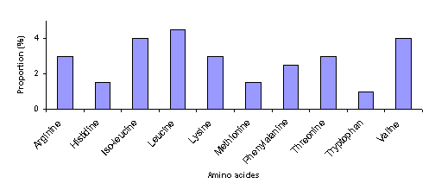
Proportion (%) of the 10 essential amino acids needed by honey bees (deGroot, 1953).
2.7. Pollen Substitute for Bees
A good pollen substitute for honey bees should have the same features as a good pollen: 1). palatability (bees will readily consume it), 2). Digestibility (it is easily digested by bees), and 3). Balance (it has the correct the amino acid balance and enough crude proteins). Currently there are four commercial pollen substitutes for honey bees in the U.S.: Bee-Pol®, Bee-Pro®, Feed-Bee®, and MegaBee®. It appears that Bee-Pro® is soy-based, and Feed-Bee® and MegaBee are non-soy-based. I have insufficient information for Bee-Pol.
Cremonez et al. (1998) fed caged bees various diets and used hemolymph protein titer to assess their quality, with higher protein titer suggesting higher quality. Six day old bees had protein concentration of 27.6, 24.1, 11.4, 3.98, and 2.2 ug/ul, for bee bread, soybean/yeast, pollen, corn meal and sucrose, respectively. De Jong et al. (2009) used the same assay to assess the quality of commercial pollen substitutes. They found that bees feeding on Feed-Bee®, Bee-Pro®, pollen, acacia pod flour diets and sucrose had hemolymph titers of 9.42, 8.95, 6.26, 6.0 and 3.56 ug/ul, respectively. It would be informative to see if the high protein in blood translates to longer life in either cages or small colonies.
3. Other Nutrition
3.1. Sterols and Lipids
A sterol, 24-methylene cholesterol, is common in pollen and is the major sterol source for honey bees. Nearly all insects need to obtain sterol from their diet because of their inability to synthesize them directly. Sterol is the precursor for important hormones such as molting hormone, which regulates growth because it is required at the time of each molt. It is not clear what other lipids are required by honey bees, but most likely normal consumption of pollen provides for all the lipid requirements. Pollen with low fat content is less likely to be consumed by honey bees, but can be made more attractive to bees with the addition of lipids. The total lipid concentration within a pollen supplement is recommended to be 5%–8%.
3.2. Vitamins
Nurse bees are thought to need the following vitamin B complex for brood rearing: thiamine, riboflavin, nicotinamide, pyridoxine, pantothenic acid, folic acid, and biotin. Ascorbic acid (vitamin C) also seems essential for brood rearing. Like sterol and lipids, the vitamin needs of a honey bee colony are satisfied if pollen stores are abundant in the hive or fresh pollen is being brought into the colony. It is not known whether micro-organisms naturally present in the alimentary canal of bees may play a role in providing vitamins and other essential substances.
3.3. Minerals
The mineral requirements of honey bees are poorly understood. High amounts of potassium, phosphate, and magnesium are required by all other insects, and so presumably are by honey bees as well. Excessive levels of sodium, sodium chloride, and calcium have been shown to be toxic to honey bees. Again, all the required minerals can be obtained from pollen, although nectar also contains minerals. Dark honey contains higher levels of minerals. The optimal ash concentration for maximum brood rearing seems to be at 0.5%–1%. Pollen with more than 2% ash inhibits brood production.
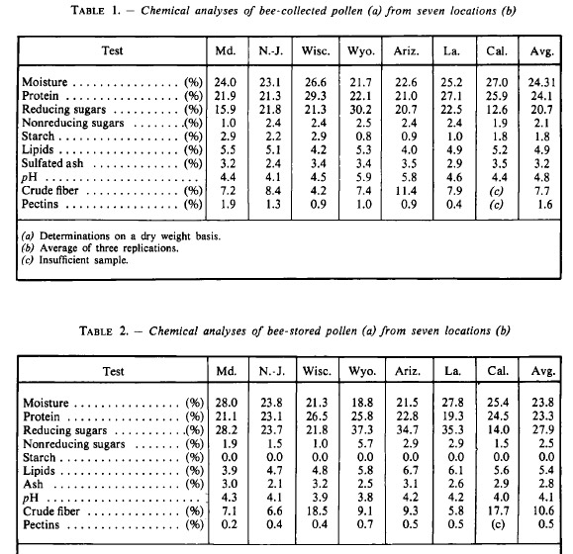
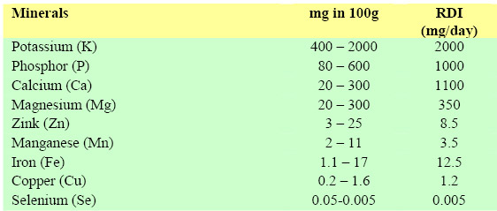
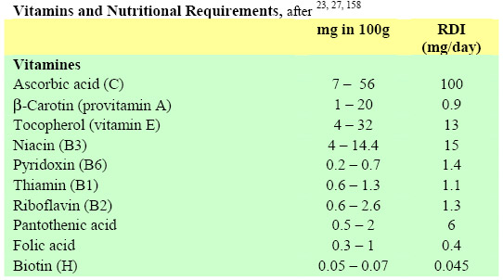
CEVTCHIK conducted microbiological analyses of fresh pollen and pollen stored in comb cells and reported four phases of microbial development in fermenting pollen that occurred during seven days from the time of the appearance of lactic acid bacteria, yeasts, indole-producing bacteria (Escherichia), and sporulating aerobic bacteria. The first phase lasted 12 hours and was characterized by the development of a heterogenous group of microorganisms including yeasts. In the second phase, anaerobic lactic acid bacteria (Streptococcus) utilized growth factors produced by the yeasts and putrefactive bacteria and lowered the pH of the pollen. The third phase was characterized by the disappearance of Streptococcus and the development of Lactobacillus that produce more acid than Streptococcus. The fourth phase, which began at the end of the seventh day, was characterized by the disappearance of the lactic acid bacteria and certain yeasts due to the large quantity of
lactic acid produced. The pollen became microbially sterile, and the pH was approximately 4. During the course of this study, HH CEIVKT isolated from fresh and fermented pollen 77 groups of yeasts that he considered to be sources of proteins, lipids, and necessary growth factors.

No significant differences were found between the total sum of ω-6 and ω-3 fatty acids in beebread and beebread mixed with honey (p > 0.01) (Table 2). The ratio of these acids in beebread samples where rape pollen constituted 45.1 ± 3.0% and 61.7 ± 4.0% was 1: 1, while in the beebread with a higher content of rape pollen (78.7 ± 4.5%) this ratio was 2 : 1. The preferable ω-6 and ω-3 fatty acid ratio (1 : 1) was found in beebread mixed with honey.
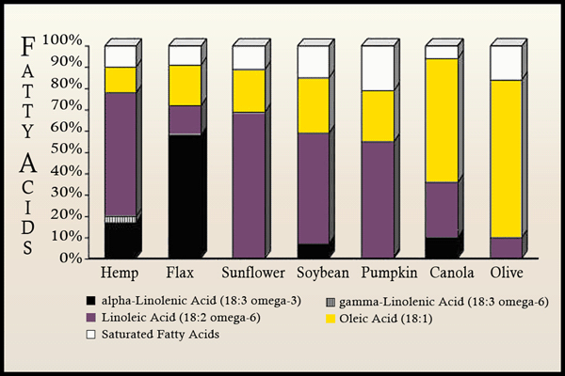

Production of “home bee bread”
Normally, the term beebread refers to the pollen stored by the bees in their combs. The beebread has already been processed by the bees for storage with the addition of various enzymes and honey, which subsequently ferments. This type of lactic acid fermentation is similar to that in yoghurts (and other fermented milk products) and renders the end product more digestible and enriched with new nutrients. One advantage is almost unlimited storability of beebread in comparison with dried or frozen pollen in which nutritional values are rapidly lost. The natural process carried out by the bees can more or less be repeated artificially with dry or fresh bee-collected pollen. It is important however, to provide the correct conditions during the fermentation process.
The container Wide-mouthed bottles or jars with airtight lids are absolutely essential. Airtight stainless steel or glazed clay pots can also be used. Containers should always be large enough to leave enough airspace (20 to 25 % of the total volume) above the culture.
The temperature
The temperature for the first two to three days should be between 28 and 320C; the bees maintain a temperature of approximately 34°C. After the first two or three days the temperature should be lowered to 20°C.
The high initial temperature is important to stop the growth of undesirable bacteria as quickly as possible. At this ideal temperature all bacteria grow fast so that an excess of gas and acid accumulates. Only lactic acid producing bacteria (lactobacilli) and some yeasts continue to grow. The former soon dominate the whole culture. This final growth of lactobacilli should proceed slowly, hence the reduction in temperature after 2-3 days.
The starter culture
It is best to start the culture with an inoculation of the right bacteria such as Lactobacillus xylosus or lactobacilli
contained in whey. Freeze-dried bacteria are best if they can be purchased, but otherwise, the best cultures are
those that can be obtained from dairies. Whey itself can be used. If the whey is derived from unprocessed fresh milk it should be boiled before use. A culture can also be started with natural beebread.
Preservation
Fermentation produces a pleasant degree of acidity (ideally pH 3.6-3.8). Some pollen species may promote
excessive yeast growth but this does not spoil the beebread. If the flavour is strange or some other mildew-like or
unpleasant odours arise from the beebread, discard it and try again. The final product, can be stored for years,
once unsealed, it can be dried and thus is storable for many more months.
General conditions
For successful fermentation, exact quantities are less important than the correct conditions:
- the pollen to be fermented needs to be maintained under pressure
- the air space above the food needs to be sufficient (20-25 % of total volume)
- the container needs to be airtight
- the temperature should not drop below 18°C
Ingredients (in parts by weight):
10 Pollen; 1.5 Honey; 2.5 Clean water 0.02 Whey or very small quantity of dried lactic acid bacteria
Clean and slightly dry the fresh pollen. If dried pollen is used, an extra 0.5 parts of water is added and the final
mix soaked for a couple of hours before placing it in the fermentation vessels. If the mixture is too dry, a little more honey-water solution can be added.
Heat the water, stir in the honey and boil for at least 5 minutes. Do not allow the mix to boil over. Let the mix cool. When the temperature is approximately 30-32 0C, stir in the whey or starter culture and add the pollen. Press into the fermentation container.
When preparing large quantities in large containers, the pollen mass should be weighted down with a couple of
weights (clean stones) on a very clean board.
Close the container well and place in a warm place (30-32 0C).
After 2-3 days, remove to a cool area (preferably at 200C). 8 to 12 days later the fermentation will have passed its peak and the beebread should be ready. The lower the temperature, the slower is the progress of fermentation.

Bee Bread. To produce bee bread, fill a container 75-80% of its volume with pollen. The container must be sealable and airtight. To this pollen add a starter culture made from Lactobacillus xylosus or Lactobacilli contained in whey. The recipe should be in parts of weight: 10 pollen, 1.5honey, 2.5 clean water, 0.02 whey or a very small quantity of dried lactic acid bacteria. Leave the container sealed for storage. The process should first take place at temperatures between 28-32℃. After two or three days this temperature should be dropped to 20℃ but not below 18℃. After 8-12 days at 20℃ the fermentation process should be complete. With the high initial temperatures this will promote the growth of the lactic acid producing bacteria over other yeasts. The desirable bacteria should dominate after two or three days. If done correctly this will preserve its nutrient value and extend its shelf life conserable, said to be almost unlimited.

Fermented Pollen Patty
1080g pollen
435g syrup (2:1 sugar:water)
60g yogurt
Mix and store the diet(s) in plastic, sealed container placed in an incubator at 30℃ for 3 days and then at room temperature (~23℃) for > 2weeks. Patties weighed 250g pressed between two sheets of waxed paper.
We used off-the-shelf “Silk Soy Yogurt” to inoculate soy-based commercially available food supplements to promote the fermentation process. We chose this product because it contained multiple fermentation bacteria: Lactobacillus bulgaricus, L. acidophilus, L. casei, L. rhamnosus, Streptococcus thermophiles and Bifidobacterium bifidum to pre-digest the soy flour and produce a near beebread-like fermented food.

